**Problem Statement:**

Twitter data analysis

Write a pig script to find the count of each Hashtag in the dataset.

You can download the twitter data from the below link Tweets_Data

**Pig Script:**

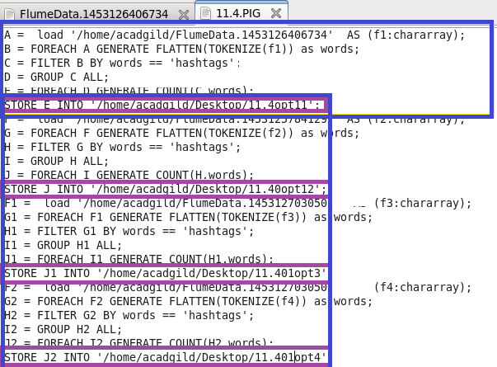

**Output:**

